Date 29.02.2024, Annual Meeting
Present:  Absent: | Mads Flensted Hauge, Steen Sjøgaard, Jørgen Lauridsen, Rasmus Jakobsen, Rasmus Bang, Heidi Sandager Larsen, Ioana Mogensen  7 DAMA DK Members  Charlotte Arbo-Bähr, Michael Bendixen
Location: | Teams-online

Agenda
1.Election of moderator
2.Election of secretary
3.Election of vote counter
4.President's report - (Mads)
5.Financial reporting for approval – (Rasmus)
6.Proposal from the Management Board:
1.Budget for 2024 – (Rasmus)
2.Updated bylaws – (Mads)
7.Election to the Management Board in accordance with the rules of § 9
  - Ioana Mogensen (up for election, wish to be re-elected)
  - Charlotte Arbo-Bähr (up for election, do not wish to be re-elected)
  - Michael Bendixen (up for election, wish to be re-elected)
  - Jørgen Lauridsen (up for election, do not wish to be re-elected)
  - Steen Sjøgaard (up for election, wish to be re-elected)
  - Rasmus Jakobsen (up for election, wish to be re-elected)
  - Rasmus Bang (elect, alternate entered 2023)
  - 1-3 substitutes – none currently elected
8.Choice of auditors
9.Discussion and voting on proposals received prior to the General Meeting
- No proposals received before deadline
10. Any other business

Minutes
Ad. 1. Mads is elected as moderator.
Ad. 2. Heidi is elected as secretary.
Ad.3. Jørgen is elected as vote counter.

Ad. 4. Mads presented:
President’s report:
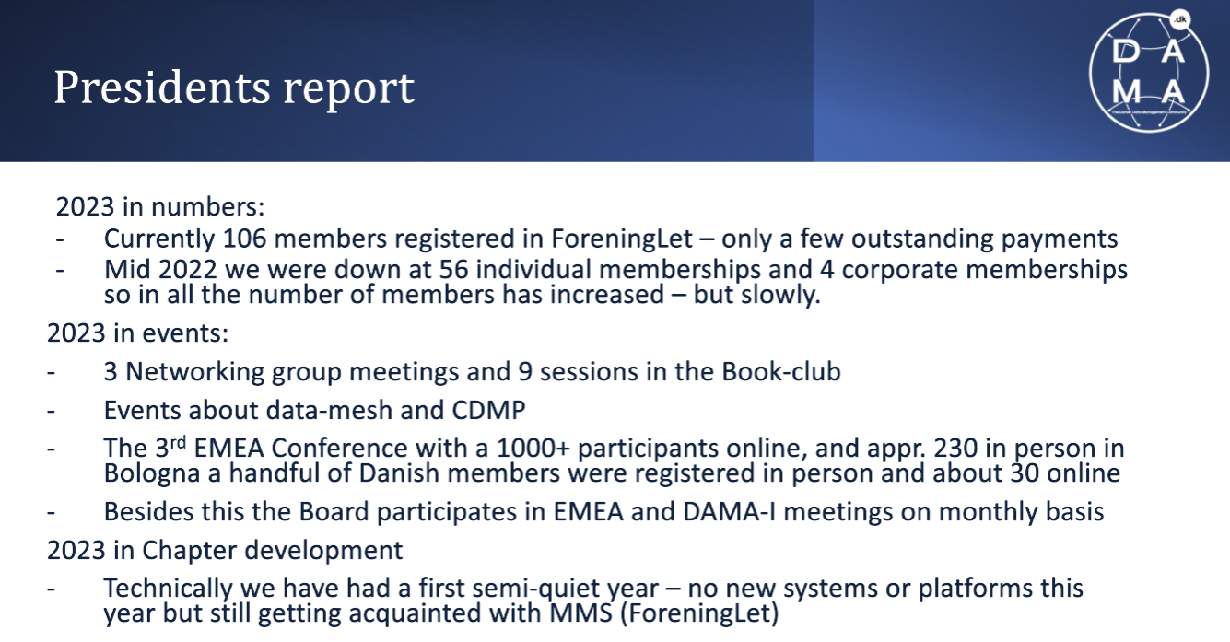
As you might have seen in an email sent directly to you yesterday evening, we have a current dispute ongoing with DAMA-I and hope to elaborate news during the coming months.

DAMA Denmark is an affiliate of DAMA-I and the affiliation is growing and keep on growing. From an EMEA initiative we’ve been a part of an EMEA oriented document that can support our EMEA part of the world. This has resulted in the fact that DAMA I has now issued a new affiliation agreement that the various chapters must sign. This new affiliation agreement makes every chapter a subordinate to the DAMA-I perspective both in terms of financial, risks and “freedom to manoeuvre” hence we in DAMA DK has decided not to sign the new agreement as also in some countries it’s illegal to sign this affiliation agreement.
Other risks like penalties and possible legal disputes in connection with American law has been a part of the decision in DAMA Denmark and the road towards a de-affiliation of our relation to DAMA I and our current name, logo etc. will change – however context, book clubs, events will still be possible but along also other data management frameworks will now be an option.

Question from the audience: How come this started?
“The guess will have to be as we cannot get a proper answer from DAMA-I the wish from DAMA-I is to have more control of the affiliations and wish to be able to control the financial flows (which currently are only floating one way)
We as DAMA DK are not contributing a lot to the financial but other EMEA Chapters have a huge pile both in terms of work with a new version of the DMBoK2 but also financials.”
Other affiliations throughout EMEA are looking into the de-affiliation too due to the exact same reasons.

Important note – please feel free to reach out to any of the board members to get more information around this topic.

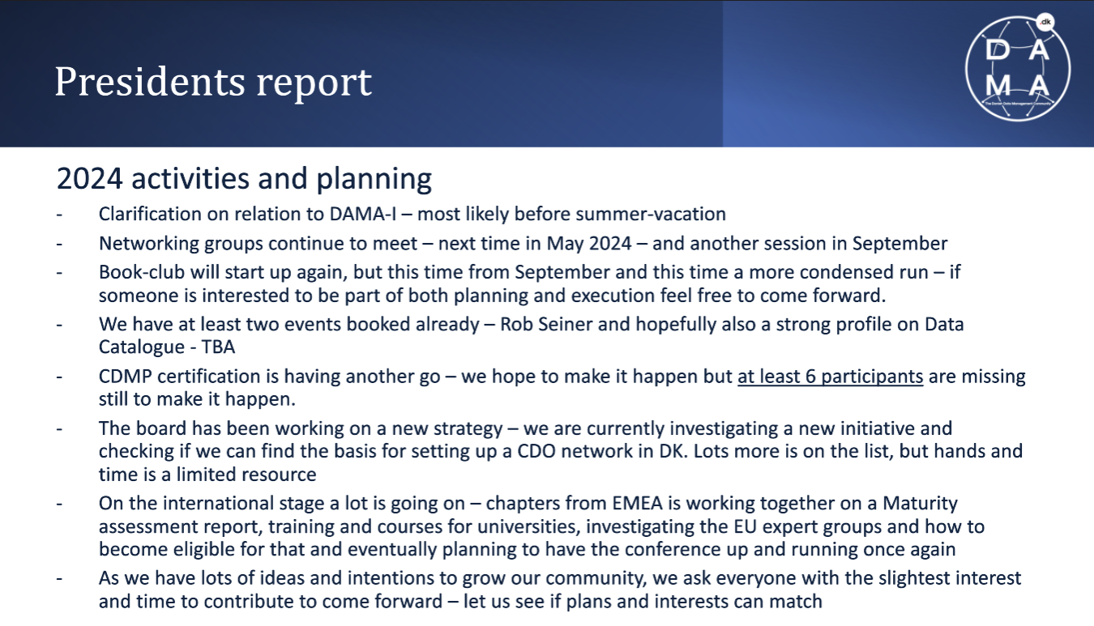
Working Groups have been set up in an EMEA context for
- Maturity Assessment
- Training and courses for universities
- Investigating the EU expert groups and how to become eligible for that
- Planning around the next EMEA DATA Conference

Ad. 5. Financial statement approved. (unanimously)
First “normal financial year” – whole year membership fees hence 2022 and 2023 not directly comparable.
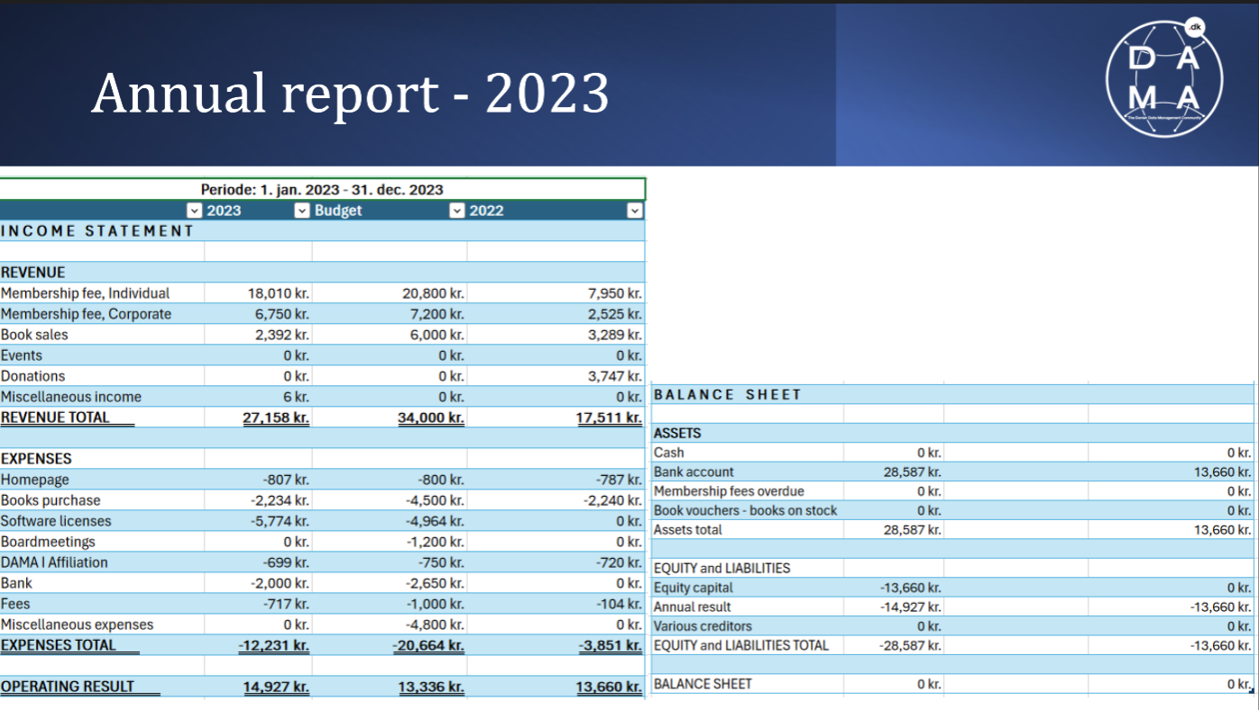
All has been reviewed and approved by our Accountant
Formally we must approve this by voting and poll exercise was provided – approved by all from poll voting on teams
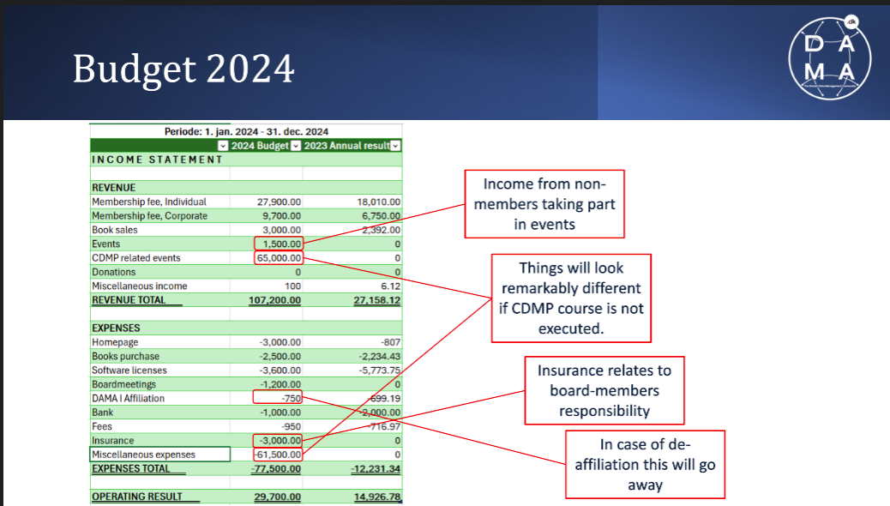

Wish to increase the book sales and budget for external attendees participating in our speaker events for a certain fee, hence fee for DAMA Denmark Members. We hope still to have the CDMP Course executed however participant dependent.
The budgeted 3.000 regarding Homepage is due to a system upgrade for better functionalities and user experience enhancements.
Formally we must approve this by voting and poll exercise was provided – approved by all from poll voting on teams

Ad. 6. Proposal from the Management Board:
1.Budget for 2023 approved. (unanimously)
Formally we must approve this by voting and poll exercise was provided – approved by all from poll voting on teams

2.Mainly minor editorial changes to Bylaws e.g., adaption to membership fees.
No questions raised. Bylaws approved (unanimously).
Depending on the outcome of discussions with DAMA- I but our legal name is to change to the Danish Data Management Community and more smaller modifications and stating more formally we operate independently and as a non-profit organization.
A small Code of Conduct setting the frames within the board operates has been generated
The limitation of board members has been removed, as more hands to drive the association will be beneficial for our momentum and listening to the experiences from other affiliation chapters.
The dissolution of the association must be approved both at the annual meeting but also during an extraordinary meeting.
New Bylaws will be accessible through our webpage: www.dama-dk.org during Week 10.2024

The new bylaws are unanimously approved during the online voting during our annual meeting.

Ad. 7. Election to the Management Board in accordance with the rules of § 9
The following persons are elected as auditor for 2024 is as follows:
- Ioana Mogensen (up for election, wish to be re-elected)
    - Re-elected
- Charlotte Arbo-Bähr (up for election, do not wish to be re-elected)
    - No longer board member
- Michael Bendixen (up for election, wish to be re-elected)
    - Re-elected
- Jørgen Lauridsen (up for election, do not wish to be re-elected)
    - No longer board member but elected as auditor
- Steen Sjøgaard (up for election, wish to be re-elected)
    - Re-elected
- Rasmus Jakobsen (up for election, wish to be re-elected)
    - Re-elected
- Rasmus Bang (elect, alternate entered 2023)
    - Now elected as Board Member
- Sevar Khusainova (elect, alternate entered 2023)
    - Now elected as Board Member
- 1-3 substitutes – none currently elected

Two new board members had volunteered and were elected:
- Pernille Helene Kjeldsen wishes to join the Board of directors and was unanimously elected
- Sandra Kristholm wishes to join the Board of directors too and equally unanimously elected
WELCOME BOTH!

Ad. 8. Choice of auditors:
Jørgen Lauridsen will take the position of auditor. Thank you Jørgen.

Ad. 9. Discussion and voting on proposals received prior to the General Meeting
•No proposals received before deadline

Ad. 10. Any other business
We briefly again talked about the dissolution of DAMA Denmark and the feeling and approach from the other DAMA EMEA Chapters.

