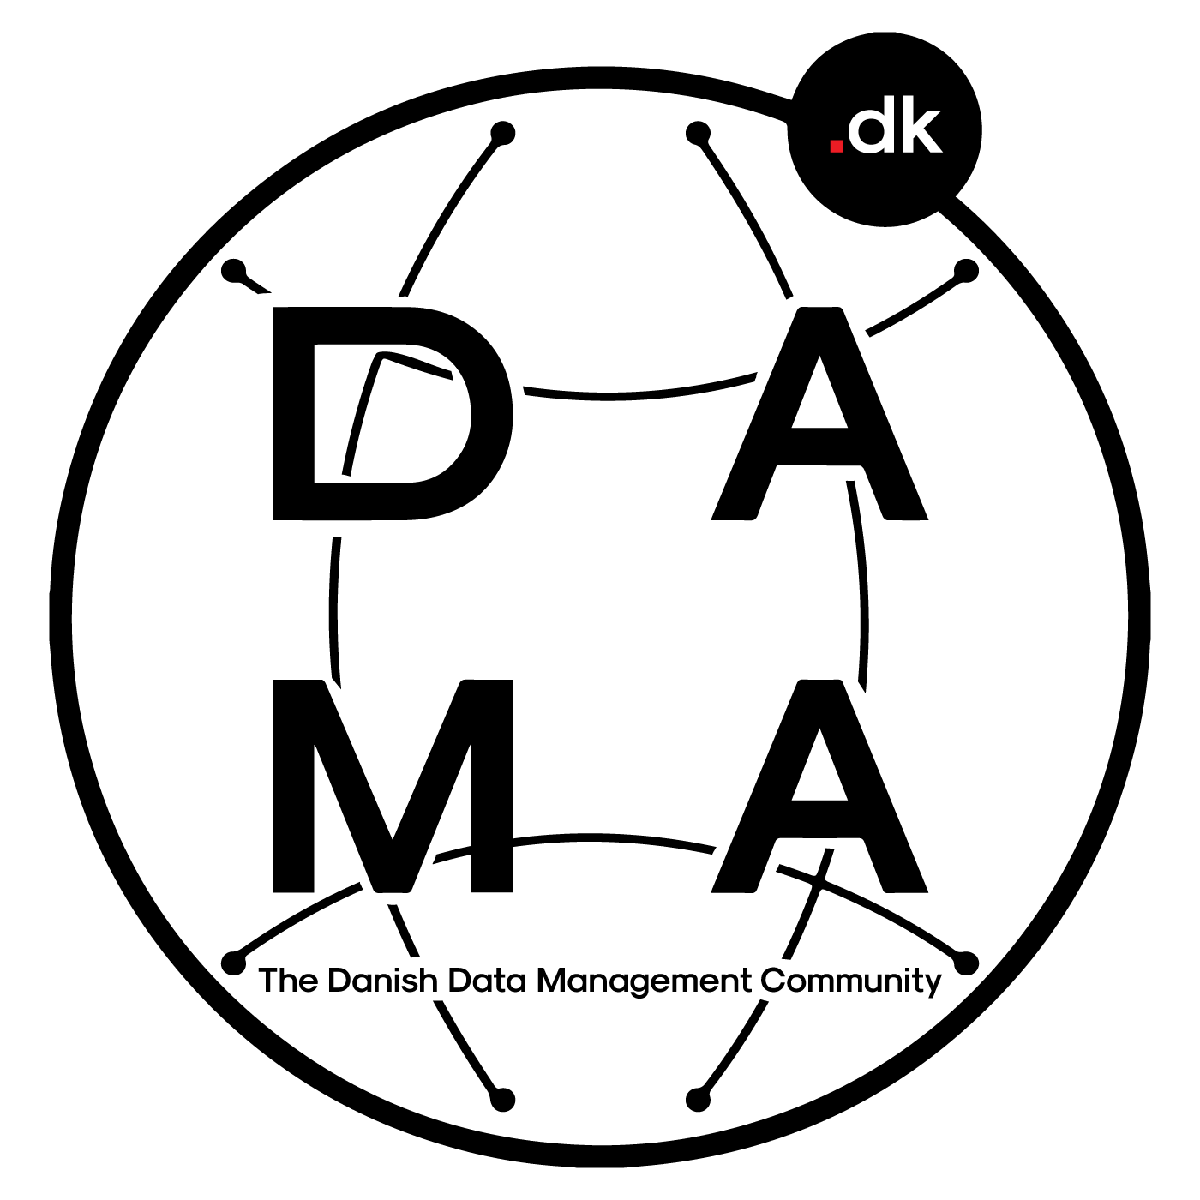

BYLAWS
OF
Danish Data Management Community

Approved at Annual Meeting, February 29th, 2024
Version 1.30
www.dama-dk.org

BYLAWS - Danish Data Management Community

§ 1
The name of the voluntary association is: "Danish Data Management Community" hereinafter called: "The association". The association is resident in Denmark.

§ 2
The purpose of the association is to advance the practice of managing information and data.

§ 3
The association is an affiliate of DAMA-International and will thus align its activities and statutes to comply with the strategic objectives of DAMA-International.

§ 4
The association is registered as a voluntary non-profit organization and operates independently of suppliers and partners.

§ 5
The Annual Meeting is the highest authority of the association. The Annual Meeting is held once a year before the end of February. Invitations are issued to all registered members 4 weeks prior to the event.

§ 6
The agenda of the Annual Meeting shall have the following items:

- Election of moderator
- Election of secretary
- Election of vote counter
- President's report
- Financial reporting and budget for approval
- Proposals from the Management Board
- Election to the Management Board in accordance with the rules of § 9
- Election of auditors
- Discussion and voting on proposals received prior to the Annual Meeting
- Any other business

Proposals to point i) must reach the Chairman of the Management board in writing no later than 2 weeks prior to the Annual Meeting. These will be communicated to all invited no later than 1 week prior to the annual meeting.

Voting is by show of hands, but if one or more participants wishes to vote secretly, this form of voting is used instead. The elected vote counter is accountable for the voting procedure and documenting the results.

Voting rights are reserved for paying members only, who are not in arrears with a quota and hold at least 3 months of membership prior to the Annual Meeting.

Meeting minutes are prepared by the elected secretary and shall be published within 2 weeks after the Annual Meeting is held. The minutes will contain a copy of the financial report and budget.

§ 6.1
An extraordinary Annual Meeting may be convened at the request of at least 2/3 of the members of the Management Board or at least 1/3 of the members that are allowed to vote at the time of the Annual Meeting. To make it a legal notice, a statement in writing with an agenda must be sent to the chairman of the Management Board. Other notices shall follow the rules of an ordinary Annual Meeting.

§ 7
Amendments to the bylaws of the association can only be made at the Annual Meeting and adopted by a two-thirds majority of the participants allowed to vote.

§ 8
All interested parties are admitted as members of the association. It is possible to subscribe for an Individual membership, a corporate membership, or a student membership. Quota rates shall be fixed at the Annual Meeting. Members with quota arrears more than 2 months delay will automatically have their membership cancelled.

§ 8.1
Student membership is free of charge. Students must be able to document being an active student. Student members may attend the Annual Meeting but do not have the right to vote at the Annual Meeting.

§ 8.2
A corporate membership does not grant voting rights to the company registered as payer for the membership. That right is only granted to the individuals registered as members under the corporate membership.

§ 9
Management Board members and alternates are elected at the Annual Meeting. All members of the association that are also eligible to vote at the time of the Annual Meeting can become a candidate. To be eligible a candidate must read, accept, and adhere to the Management Board code of conduct.

§ 9.1
The Management Board consists of a minimum of 3 members + maximum 3 alternates. Management Board members have voting rights at the Annual Meeting. Board members are elected for 2 years at a time. A simple majority shall be valid for the election of a Management Board member. The Management Board constitutes itself after the Annual Meeting and ranks the elected alternates. At the Annual Meeting, 1 auditor is elected, who cannot be a member of the Management Board.

§ 9.2
After the Management Board constitution, the Management Board can appoint Trackleads responsible for one or more of the areas referred to in §12 (point a - h).

§ 9.3
After the election, members of the Management Board gain free membership of the association.

§ 9.4
In the event of the resignation of a member of the Management Board, the highest-ranking alternate shall enter the Management Board. New alternates must be appointed by the Management Board. Alternates appointed during the term of office shall be elected at the next Annual Meeting.

§ 10
Authorized signatory for the association is treasurer and chairman of the Management Board, who jointly possesses that authority. The Management Board and the Board of Directors shall not be personally liable for the obligations entered into by the association. Only the association is liable for this with the association's current assets. The association is not allowed to take up loans or be in debt. The association's accounting period is from January to December.

§ 11

§ 12
In addition to the Management Board, several Trackleads can be appointed, whose responsibility can relate to:
- Member management
- Event management
- Professional development
- Operations
- Marketing / Communication
- Online channels
- Governance and ethical responsibility

§ 13
The dissolution of the association must be approved at both an Annual Meeting and an extraordinary Annual Meeting. The extraordinary Annual Meeting shall be convened with three weeks' notice and shall be completed no later than 1 month after the ordinary Annual Meeting.
Settlement of the association is carried out jointly by the association's auditor and the association's signatories. Any excess funds in the association accrue to the association's debtors first and the remaining balance equally amongst the paying members of the association.

Version | Comments | Approved by/date
1.10 | Initial version – sent to DAMA-I and approved as part of initiation of the DAMA Denmark chapter. | Founding annual meeting/10.9.2020
1.20 | Revision proposed to Annual meeting 2023 – clarification and streamlining wording and content. Adapting to paid membership and clarifying approval of budget in Agenda for annual meeting. | Annual meeting / 28.2.2023
1.30 | Revision in progress up till Annual Meeting 2024

